**Smith Corporation**

is a Proud Participant in the

Nationwide SIDS Awareness Day and Fundraising Event

For further information contact Betty Jones at [bettyjones@smith.com](mailto:bettyjones@smith.com) or 555-444-3333.

### Join in the fight against SIDS.

### All proceeds go to the American SIDS Institute

Our Participation is dedicated to the memory of a very special infant who died of

Sudden Infant Death Syndrome.

Mary was the child of Peter and Jane Thomas.

# Mary Jane Thomas

# June 30, 2004 - October 1, 2004

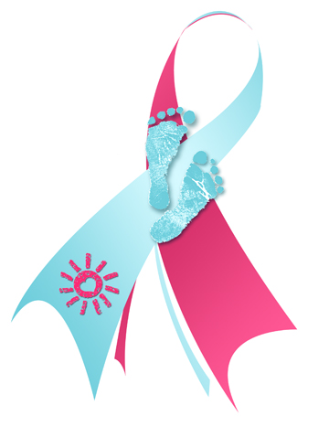

#### *Spring-for-SIDS*

#### *Day*

##### Friday,

##### May 17, 2019