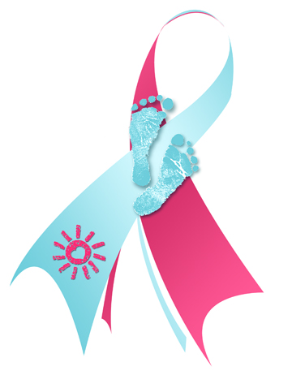
for immediate release:
Smith Company, located in Smithville, is the local sponsor of Spring-for-SIDS Day. This is a SIDS awareness and fundraising event being held on May 17, 2019 to benefit The American SIDS Institute. “We are proud to be a part of this nation-wide event,” explains John Lee, vice president of HR.

SIDS or Sudden Infant Death Syndrome is the name given to a mysterious baby killer that takes the lives of between 2000 and 3000 infants each year in the US. It is the number one cause of death in infants between one month and one year of age. SIDS is sudden and unexpected and even after an autopsy no cause of death is found. In a typical situation, parents check on their infant they think is sleeping only to find their baby dead. There is no greater tragedy!

Spring-for-SIDS Day is especially important to Smith Company. One of their employees, Jane Thomas, lost a baby to SIDS in October of 2003. Jane and her husband Peter were enjoying their 3-month-old baby girl, Mary. Mary had recently started giving her dad the biggest smile when he walked into her room – a smile that melted his heart. One morning Jane and Peter woke up feeling good that Mary was beginning to sleep through the night without waking for a feeding. Jane went in to check on her. “I remember hearing this terrifying scream, and then I realized that it was coming from my own mouth” said Jane. Mary was lying in her crib lifeless. Peter was immediately by her side. “I knew instantly,” Jane said, ”by the empty look in Peter’s eyes, that our baby girl was dead. Life as we knew it was over.”

Peter recounted a harrowing story. We followed the paramedics to the hospital where Mary was pronounced dead. “Dead? How could our little girl, so healthy and full of life, be dead? It just couldn’t be possible.” Jane explains how she immediately felt that she was responsible. “I must have done something wrong, or missed something. She was so little, so dependent on me. I was her mother. “

Every day unfortunate parents all over the world experience this heartbreak. Dr. McEntire, with the American SIDS Institute has worked with SIDS since 1976. “We have seen a tremendous decline in the incidence of SIDS since I began,” she explained. “However, we still cannot tell parents why their infant died. They are left with no closure.”

We don’t know the exact cause of SIDS, and there is no way to guarantee an infant will not die,” says Dr. McEntire. “However,” she explains, “there are proven ways to reduce the risk of an infant dying suddenly. Don’t smoke during pregnancy and don’t let anyone smoke around your baby. Always place your baby to sleep on his or her back in a bare crib. Keep the crib close to the parents’ bed. Instead of using cover, put enough clothing on the baby to keep him/her warm but not too warm.” For a full list see www.sids.org.

Spring-for-SIDS Day will be held on May 17. Employees at Smith Company in exchange for a donation will be given a SIDS information card and a decorative sticker. On May 17, all employees with Spring-for-SIDS stickers will be encouraged to wear their casual spring outfits. Mr. Lee says he expects to see many employees in Hawaiian shirts and sandals. “This is a great way to educate people about SIDS, raise funds for research and have a lot of fun.”

For further information contact
- Betty McEntire, PhD, Executive Director, American SIDS Institute, Naples, Florida
1-800-232-7437
- John Lee, Vice President HR, Smith Company, Smithville, MD, 888-999-7777.
- Peter and Mary Thomas, 888-999-2222.

