Smith Corporation
is a Proud Participant in the
Nationwide SIDS Awareness Day and Fundraising Event
For further information contact Betty Jones at bettyjones@smith.com or 555-444-3333.

Join in the fight against SIDS.

All proceeds go to the American SIDS Institute
Our Participation is dedicated to the memory of a very special infant who died of
Sudden Infant Death Syndrome.
Mary was the child of Peter and Jane Thomas.

Mary Jane Thomas

June 30, 2004 - October 1, 2004

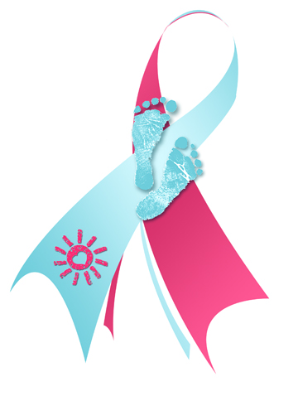

Spring-for-SIDS

Day

Friday,

May 12, 2017

